20 facts about North Korea
USA TODAY research11:53 a.m. EDT April 13, 2013
1. The founder of North Korea, first president Kim Il Sung, created the country's policy of juche or "self-reliance," which has essentially cut off North Korea economically and diplomatically from the rest of the world even in times of great need such as famines.
2. Kim Jong Il, son of the country's founder, has been said by state media to have managed amazing feats: He scored a perfect 300 the first time he went bowling and sank 11 holes-in-one the first time he played golf.
3. Between 150,000 and 200,000 North Koreans live in prison camps surrounded by electrified fencing, according to South Korean government estimates and Human Rights Watch. The worst camps are for those who commit political crimes, and offenders can have their entire extended family imprisoned with them. As many as 40% of camp prisoners die from malnutrition while doing mining, logging and agricultural work with rudimentary tools in harsh conditions, according to a 2011 Amnesty International report.
4. Only military and government officials can own motor vehicles.
5. North Koreans must abide by one of 28 approved haircuts. Unmarried women must have short hair, but married woman have many more options. The hair of young men should be less than 2 inches long, older men can go as long as 2¾ , according to a Taiwanese website WantChinaTimes.
FULL COVERAGE: North Korea crisis
6. All legal televisions are tuned to state-controlled domestic programming. The Internet does not exist other than a closed domestic network. Cellular 3G access is allowed to foreigner visitors. Few North Koreans know anything about world events apart from how they are described by North Korean propaganda.
7. North Korea's missile program was first developed with help from the then-Soviet Union in the 1970s. Its Taepodong-2 missile has an estimated range of more than 4,100 miles but has yet to be test-fired. Other medium-range missiles are capable of being fired over Japan.
8. The border between North Korea and South Korea is one of the most militarized in the world, according to the State Department. Pyongyang has about 1.2 million military personnel compared with 680,000 troops in South Korea, where 28,000 U.S. troops are also stationed. Nearly 6 million North Koreans are reservists in the worker/peasant guard, compulsory to the age of 60.
9. The World Food Programme estimates that 6 million of North Korea's 25 million people are in need of food aid and one-third of children are chronically malnourished or stunted. Analysis of escapees from North Korea shows that those born after the Korean War in the late 1950s were on average about 2 inches shorter than South Koreans. Most North Koreans subsist on corn and kimchi, a pickled cabbage.
10. In 1978, North Korean agents kidnapped South Korean film director Shin Sang Ok and his wife, actress Choe Eun Hui, to create a film industry in North Korea. The couple escaped to the West eight years later, after having made dozens of films.
11. The elder brother to current leader Kim Jong Un, Kim Jong Nam, was passed over to become the heir apparent leader after being arrested in Tokyo in 2001 for traveling to Disneyland on a forged passport.
12. As many as 2 million people died as a result of famine in the 1990s caused by erratic government farming policies and flooding, according to the United Nations. Asia Press reported that a recent return of famine in the farming provinces of North and South Hwanghae has forced some to resort to cannibalism.
13. North Korea spent about one third of its national income on the military, according to a 2011 report from the South Korean government.
14. Annual GDP per capita is about $1,800, which ranks 197th in the world, according to the CIA World Factbook. The GDP is 18 times higher in South Korea.
15. Electric power largely shuts down at night, and the homes that have electricity often receive only a few hours per day.
16. Schoolchildren provide their own desks and chairs, and money to pay for heat. Some students are forced to produce goods for the government. Some parents keep their children home by bribing teachers to keep quiet.
17. North Korea's regime gets much of its income by exporting to Japan and elsewhere counterfeit pharmaceuticals, narcotics such as methamphetamine, counterfeit cigarettes and fake $100 U.S. bills, and by selling small arms and missile parts to terror groups and rogue nations.
18. Nearly all property belongs to the state. A modern independent judicial system does not exist. Religious freedom does not exist.
19. Foreign investment in North Korea reached $1.4 billion in 2010, according to the United Nations Conference on Trade and Development. European and Chinese companies have opened casinos for tourists and invested in mines for copper, nickel, zinc, iron and gold. Mineral reserves are estimated to be worth $6 trillion, says South Korean state mining company Korea Resources.
20. North Korea has a network of informants who monitor and report to the authorities fellow citizens they suspect of criminal or subversive behavior. Unauthorized access to non-state radio or TV broadcasts is severely punished.
1948
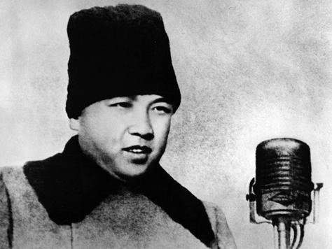
Division
Korea officially divides into two nations. Kim Il Sung installed as leader of North Korea.
Photo: Kim Il Sung attends the military parade celebrating the creation of the North Korean People's Army in February 1948.(Korean Central News Agency)

June 25, 1950
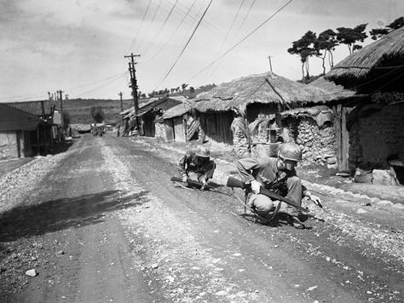
Korean War
North Korea launches a surprise attack on the South along the 38th Parallel, established as a border after the end of World War II, setting off the Korean War. Chinese troops enter the water in October, attacking U.S.-led forces that are invading North Korea.
Photo: Two U.S. 2nd Infantry Division soldiers use a screwdriver and bayonet tip as they probe for mines on the road from Changnyong to the Naktong River in South Korea on Sept. 10, 1950. (AP file photo)

July 27, 1953
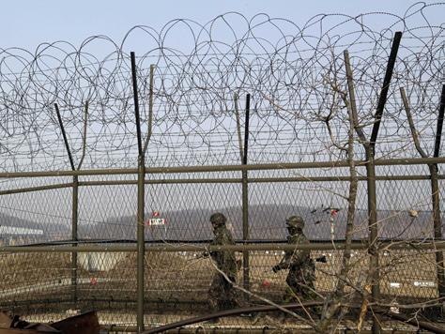
War ends
After a seesaw conflict that leaves 178,000 dead, an armistice agreement is signed, and fighting stops.
Photo: South Korea army soldiers patrol along the barbed-wire fence on March 6, 2013, near the border village of Panmunjom, which has separated the two Koreas since the Korean War. (Lee Jin-man, AP)

Jan. 23, 1968
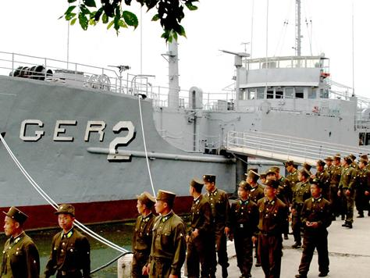
Ship captured
North Korea captures the USS Pueblo, a naval intelligence ship. The crew, minus those killed, is released 11 months later.
Photo: North Korean soldiers walk past the USS Pueblo in Pyongyang in 2006. (Korea Central News Agency via AP)

1991
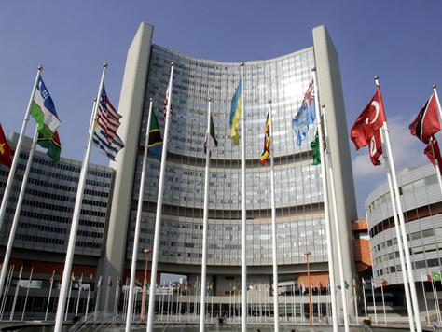
United Nations
North and South Korea join the United Nations.
Photo: The U.N. building is seen in Vienna, Austria. (AP file photo)

July 8, 1994
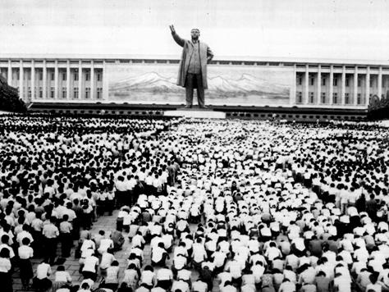
New leader
Kim Il Sung dies and son Kim Jong Il takes over as North Korean dictator.
Photo: Mourners gather in Pyongyang city center on July 9, 1994, in front of a statue of Sung. (Korean News Service via AP)

September 1995
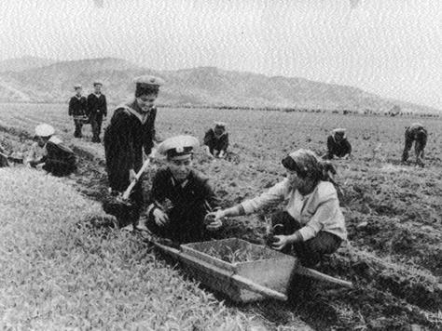
Famine
Reports surface of growing famine from food shortages, a crisis that will last years and kill about 1 million North Koreans.
Photo: North Korean sailors help local farmers prepare corn seedings for planting at a cooperative farm in Kangwon Do in 1997.(Korea News Service via AP)

August 1998
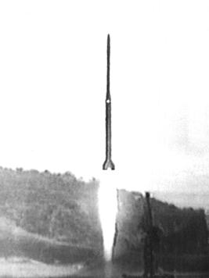
Rocket launch
An early rocket launch gains the world's attention because it goes well beyond North Korea's known capability.
Photo: A North Korean multistage rocket is launched. (Korea News Service via AFP/Getty Images)

June 15, 1999
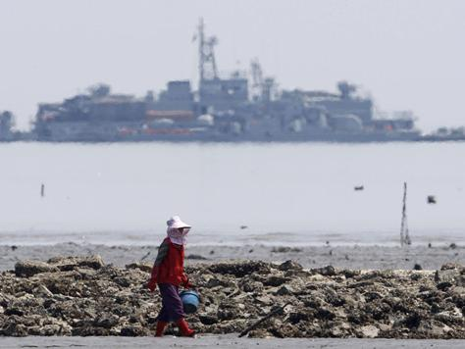
Island dispute
The first of three combat campaigns between North and South Korea over disputed western islands -- the others occur in 2002 and 2009 -- will leave several patrol ships sunk and sailors killed on both sides.
Photo: A South Korean walks along an oyster field with a sea base for naval ships seen off Yeonpyeong Island in 2009 in disputed waters in the Yellow Sea, the scene of inter-Korean clashes. (AFP/Getty Images

June 2000
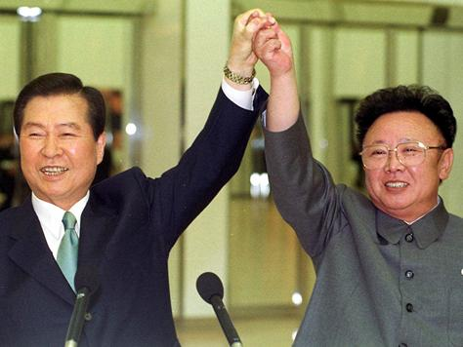
Historic meeting
North Korea's Kim Jong Il meets with South Korean President Kim Dae Jung at a summit in Pyongyang, paving the way for the reopening of border liaison offices. The South also grants amnesty to thousands of North Korean prisoners.
Photo:?Kim Jong Il, right, and Kim Dae Jung raise their arms together before signing a joint declaration at the end of the second day of a three-day summit in Pyongyang on June 14, 2000. (AP file photo)

January 2002
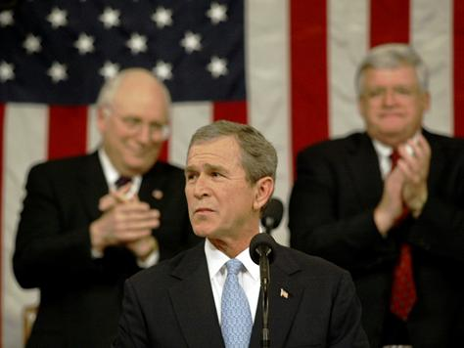
Axis of evil
President George W. Bush labels North Korea as part of an "axis of evil" and an "outpost of tyranny."
Photo: Bush, flanked by Vice President Dick Cheney, left, and House Speaker Dennis Hastert, acknowledges applause in the House Chamber of the Capitol during his State of the Union Address on Jan. 29, 2002. (Luke Frazza, AP)

January 2003
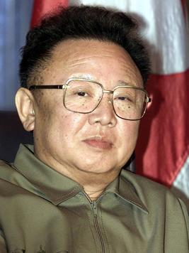
Nuclear Non-proliferation Treaty
North Korea announces it is withdrawing from the 1968 Nuclear Non-proliferation Treaty, under which the country was barred from making nuclear weapons.
Photo: Kim Jong Il is seen during a visit to Russia in 2002. (AP file photo)

Feb. 10, 2005
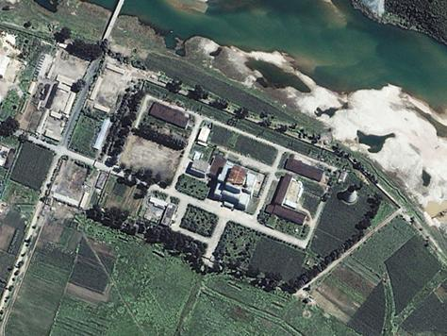
Nuclear weapons
North Korea says it has nuclear weapons.
Photo: This satellite image shows the Yongbyon Nuclear Center in North Korea on Aug. 13, 2002. (Space Imaging Asia via AP)

Oct. 6, 2006
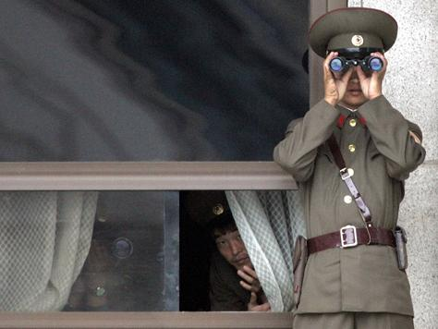
Nuclear detonation
North Korea announces it has successfully detonated a nuclear device.
Photo: North Korean soldiers observe the South Korean side through binoculars at the truce village of Panmunjom in the demilitarized zone that separates the two Koreas on Nov. 1, 2006. (Lee Jin-man, AP)

- November 2007
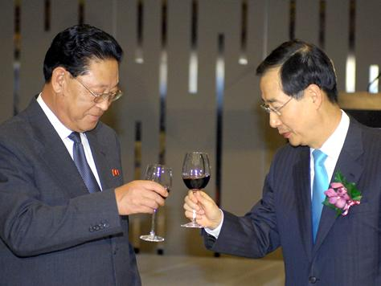
Prime ministers meet
The prime ministers of North and South Korea meet for the first time in 15 years.
Photo: North Korean Prime Minister Kim Jong Il, left, toasts South Korean Prime Minister Han Duck Soo during a dinner for the inter-Korea highest-level meeting at a hotel in Seoul on Nov. 14, 2007. (Jung Yeon-Je, AP)

May 26, 2009
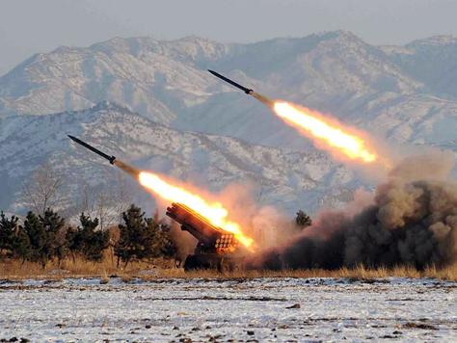
Second nuclear detonation
Second detonation of a nuclear device is a partial success with a larger yield that still falls below the threshold experts consider a successful blast.
Photo: A missile-firing drill is conducted at an undisclosed location in North Korea(Korean Central News Agency via AFP/Getty Images)

Sept. 28, 2010
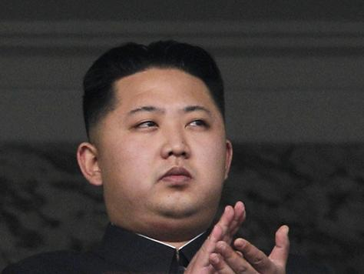
Kim Jong Un
Kim Jong Il announces that son Kim Jong Un has been made a four-star general and will be his successor.
Photo: Kim Jong Un attends a military parade on Oct. 10, 2010. (Vincent Yu, AP)

Dec. 17, 2011
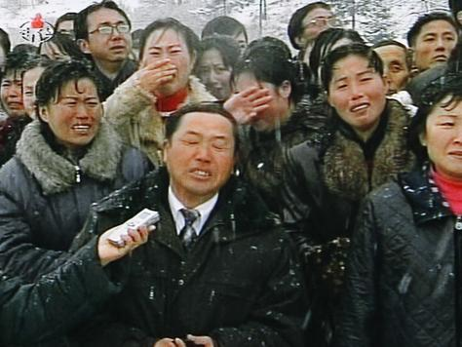
Kim Jong Il dies
Kim Jong Il dies of a heart attack at 69.
Photo: Mourners cry during a funeral procession for Kim Jong Il in Pyongyang, North Korea, on Dec. 28, 2011. (KRT via AP)

April 2012
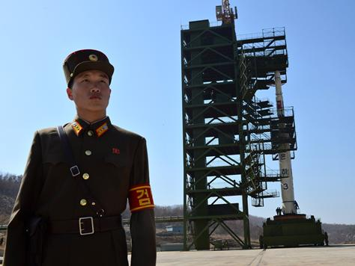
Rocket failure
Launch of Unha-3 rocket ends in an embarrassing failure, splintering into pieces over the Yellow Sea soon after takeoff. Hours later, the country acknowledges that the satellite failed to enter orbit in an announcement on state TV.
Photo: A North Korean soldier stands guard in front of an Unha-3 rocket at Tangachai-ri space center on April 8, 2012. (Pedro Ugarte, AFP/Getty Images)

Dec. 12, 2012
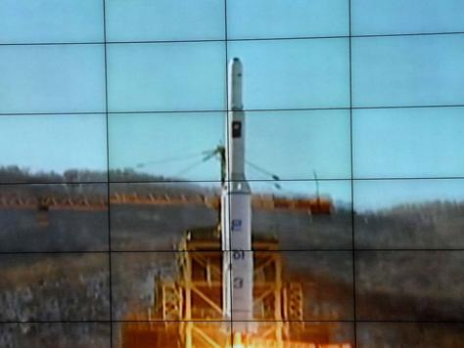
Satellite launch
North Korea launches a long-range rocket and succeeds in its mission to place a satellite into orbit.
Photo: The launch of rocket Uhna-3, carrying the satellite Kwangmyongson-3, is monitored on a large screen at a control center on Dec. 12, 2012. (Korean Central News Agency via AFP/Getty Images)

Feb. 12, 2013
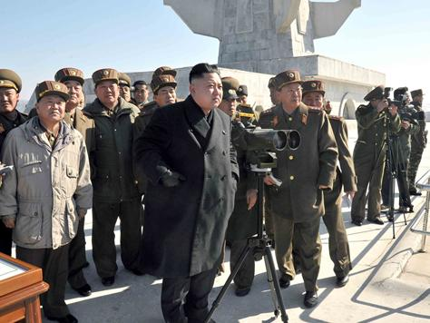
Miniature nuclear device detonated
North Korea says it has detonated a miniaturized nuclear device. If true, this would be an advance, as North Korea needs to master the technology to make a nuclear device small enough to mount on a missile.
Photo: North Korean leader Kim Jong Un watches a live ammunition firing drill.(Korean Central News Agency via AP)

March 8, 2013
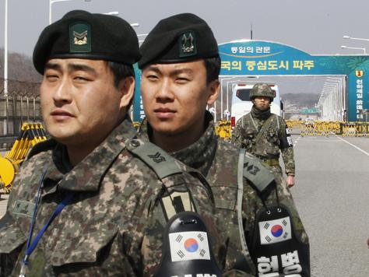
Armistice agreement scrapped
North Korea announces it will scrap the armistice agreement that ended the Korean War 60 years ago.
Photo: South Korean Army soldiers stand guard at the Unification Bridge near the border village of Panmunjom on March 21, 2013. (Ahn Young-joon, AP)

March 15, 2013
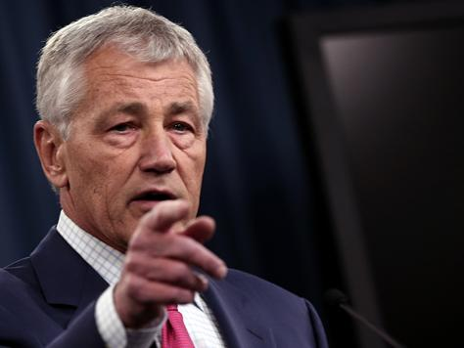
USA beefs up defense
Defense Secretary Chuck Hagel says the Pentagon will bolster missile defense in the U.S. with the addition of 14 interception missiles in the face of a growing threat from North Korea. The decision expands the system's ability to shoot down long-range missiles in flight before they could reach U.S. territory.
Photo: Hagel speaks about the U.S. missile defense system during a press briefing at the Pentagon on March 15, 2013. (Win McNamee, Getty Images)

March 30, 2013
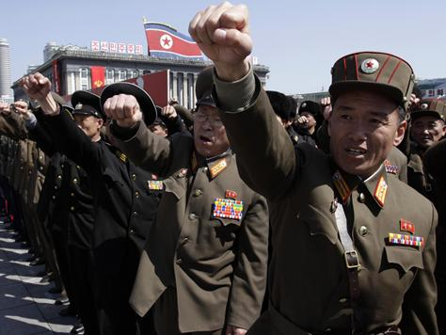
'State of war'
North Korea declares it has entered a "state of war" with South Korea in the latest string of threats that have raised tensions on the Korean Peninsula.
Photo: North Korean army officers punch the air as they chant slogans during a rally in Pyongyang, North Korea, on March 29, 2013. (Jon Chol Jin, AP)

