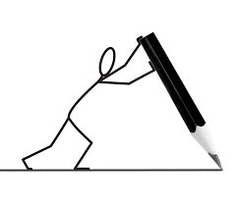

Framed Body Paragraph

*When you see a callout = Insert a Transition Word

Topic Sentence: state the main idea of your paragraph (Start w/ Transitional Word)
Thesis Statement: a.) teens can be reckless b.) they need more practice c.) they like to show off for friends

- For example, teenageers have a reputation for being reckless and dangerous when behind the wheel.
- In the same way, teens need at least three years of practice driving with a learner’s permit before they are given a license.
- Also, teens have been known to pack a car full of friends and drive too fast, often without seatbelts.

Evidence: Quotes, paraphrased information, details, examples, reasons
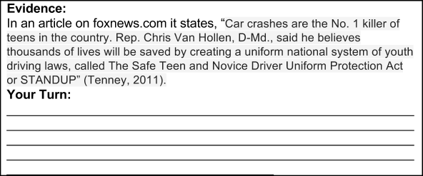
Explanation: Explanation (2 sentences) – What does the evidence say? What does it mean? Why does it matter?
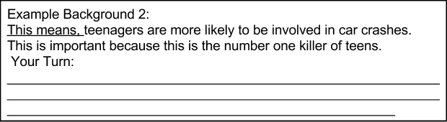

Summary Statement: Conclude with a final (new) idea that leads to your next paragraph

TRANSITIONAL WORDS:

Addition:
indeed, | further, | as well (as this), | either (neither), | not only (this) but also (that) as well,
also, | moreover, | what is more, | as a matter of fact, | in all honesty,
and, | furthermore, | in addition (to this), | besides (this), | to tell the truth,
or, | in fact, | actually, | to say nothing of,
too, | let alone, | much less | additionally,
nor, | alternatively, | on the other hand, | not to mention (this),

Introduction:
such as, | as, | particularly, | including, | as an illustration,
for example, | like, | in particular, | for one thing, | to illustrate
for instance, | especially, | notably, | by way of example,

