Introduction

Framed Paragraph

*When you see a callout = Insert a Transition Word

Hook/Lead/Grabber: (Question, Strong Statement, Statistic, Interesting Fact, ect.)
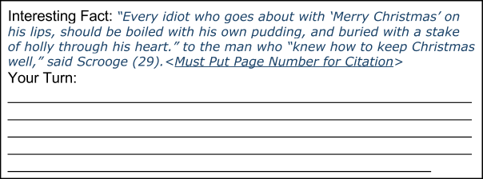
Focus Statement One: (Background on Story)
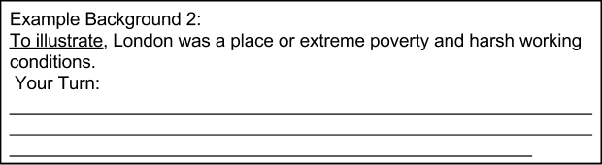
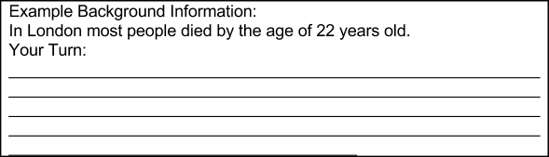
Focus Statement Two: (Background on Story)

TAG (Title, Author, Genre) THESIS:

In (author)’s (genre) (title) the theme is _________________. The author also uses (literary element), and (literary element) to tell his story.
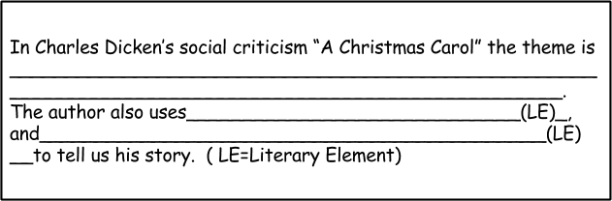
*Literary Elements = Tone, Symbolism, Setting,& Imagery
(Advanced learners ask your teacher about Allegory.)
Summary Statement: Conclude thesis and transition into new idea.
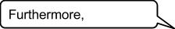

TRANSITIONAL WORDS:

Addition:
indeed, | further, | as well (as this), | either (neither), | not only (this) but also (that) as well,
also, | moreover, | what is more, | as a matter of fact, | in all honesty,
and, | furthermore, | in addition (to this), | besides (this), | to tell the truth,
or, | in fact, | actually, | to say nothing of,
too, | let alone, | much less | additionally,
nor, | alternatively, | on the other hand, | not to mention (this),

Introduction:
such as, | as, | particularly, | including, | as an illustration,
for example, | like, | in particular, | for one thing, | to illustrate
for instance, | especially, | notably, | by way of example,

