Ex-NBA star Rodman gives a "birthday present" to North Korean leader
By Associated Press, adapted by Newsela staff
Grade Level 7
01.06.14
Word Count 753
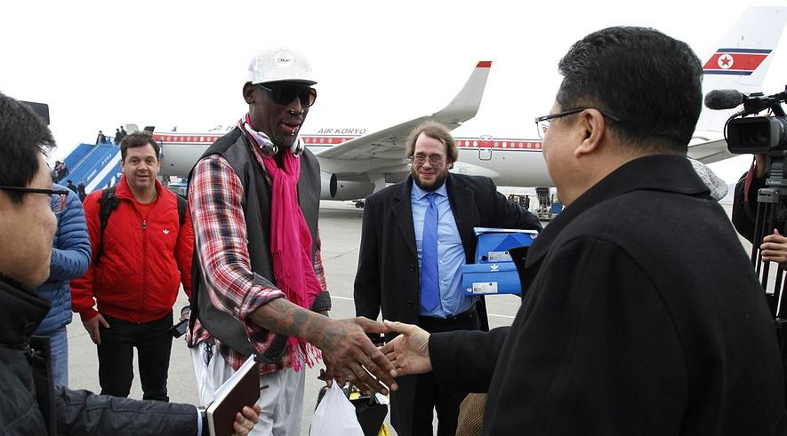
PYONGYANG, North Korea — Dennis Rodman is giving a "birthday present" to one of his most unlikely fans: North Korean leader Kim Jong Un. Rodman made the remarks on Monday. He and other former National Basketball Association players are playing a rare game in the country that is cut off from much of the world.
Rodman's squad includes ex-All Stars Kenny Anderson, Cliff Robinson and Vin Baker. They will play against a team of North Koreans on Wednesday, which is believed to be Kim's birthday. The former NBA players, who arrived in Pyongyang on Monday, also include Eric "Sleepy" Floyd, Doug Christie and Charles D. Smith, who played for the New York Knicks. Four streetballers are also on the squad.
Rodman told The Associated Press he was glad to be in North Korea for the game, though he said he has gotten death threats for his repeated visits. He said money from the game would go to a charity for the deaf in North Korea.
"The marshal is actually trying to change this country in a great way," Rodman said of Kim, using the leader's official title. "I think that people thought that this was a joke, and Dennis Rodman is just doing this because fame and fortune." Instead, he said, he sees the game as a "birthday present" for Kim and his country.

Calls Kim A "Friend For Life"
"Just to even have us here, it's an awesome feeling. I want these guys here to show the world, and speak about North Korea in a great light," he said. "I hope people will have a different view about North Korea."
The game will be another stage in Rodman's surprising relationship with Kim, who rarely meets with foreigners and about whom very little is known outside of North Korea. Rodman is the most famous American to meet Kim since the leader inherited power after his father, Kim Jong Il, died in late 2011.
Rodman traveled to North Korea for the first time last February with the Harlem Globetrotters for an HBO series. After spending time together, Rodman called Kim a "friend for life." Rodman came back just before Christmas to hold tryouts for the North Korean basketball team, though he did not meet with Kim then.
The Hall of Fame basketball player has been given the red-carpet treatment on each of his trips. But visiting North Korea for any high-profile American is very risky politically. To keep the game itself friendly, the two sides will only play against each other in the first half, and then mix together in the second.
Americans are regarded as enemies in North Korea. The two countries never signed a peace treaty to formally end the 1950-53 Korean War. Thousands of U.S. troops are still based in South Korea, and the Demilitarized Zone between the North and South is one of the most heavily armed borders in the world.
Relations are also tense because of the North's development of nuclear weapons. It has made threats to use them if a conflict breaks out with the U.S. or South Korea. Rodman has also been slammed for not trying to use his influence with Kim to secure the release of Kenneth Bae. Bae is an American missionary with health problems who is being held in North Korea on charges of committing "anti-state" crimes.

Kim's Uncle Executed
Other events make the trip more complicated. Kim's once-powerful uncle was recently executed for a long list of alleged crimes, including trying to divide the government and take power from Kim. The political killing has made people in other countries wonder about the North Korean government's unity. But North Korean officials say the execution settled the issue and there is no instability.
Rodman, however, says none of that is his concern.
"I'm not a president, I'm not a politician, I'm not an ambassador," he said before arriving. "I'm just an athlete and the reason for me to go is to bring peace to the world, that's it. That's all I want, no money. I want no money, no money."
Former Knicks player Smith said he hopes the game will lead to better relations between the two countries.
"It's new being here," but the idea of such a game isn't, he said. "The team is made up of a lot of guys who really care, that's the most important, it's not about bringing dream-teamers. It's about guys who are coming that want to be a part of this, that care, and really that care about humanity."

