WorldViews

Did North Korea really admit to its horrific forced labor camps? Not exactly.

By Adam Taylor October 9, 2014
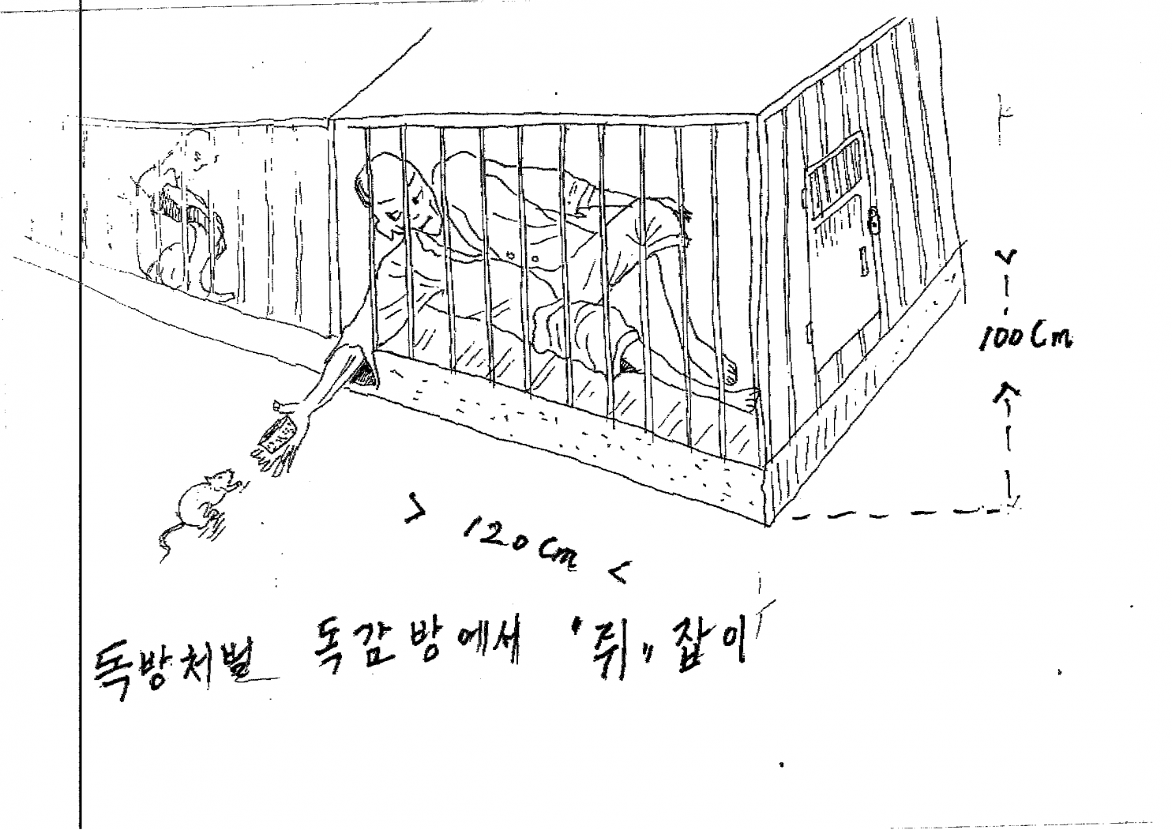
This drawing by Kim Kwang-il, a former prisoner in North Korea, comes from a U.N. report on human rights in the country.
There's some slightly unusual stuff happening in North Korea at the moment. Most obviously, Kim Jong Un, the country's omnipresent supreme leader, has been out of the public eye for a long time, and no one seems to know quite why. Receiving less fanfare (though perhaps just as important) is the news that North Korean officials have made the rare decision to hold high-level talks with the South.
Given that, the news that North Korea seems to have admitted that its notorious labor camp system really does exist would seem to fit into a cluster of potentially hopeful signs. Unfortunately, it may not be so simple.
The Associated Press reported Tuesday that Choe Myong Nam, a North Korean foreign ministry official in charge of U.N. affairs and human rights issues, had recently admitted that the camps existed in a U.N. briefing. "Both in law and practice, we do have reform through labor detention camps — no, detention centers — where people are improved through their mentality and look on their wrongdoings,” Choe reportedly said.
In the past, North Korea has completely denied any reports of the existence of a labor camp system. However, there has been growing criticism of the camps from outside sources. In 2003, the Committee for Human Rights in North Korea released a report that examined what it called a "Hidden Gulag" in North Korea: The second edition of that report, released in 2012, estimated that there were 150,000 to 200,000 people in the labor camp system, which it said had operated for decades. The camps have clearly been identified in satellite photos, and accounts from survivors (such as that told in former Post reporter Blaine Harden's book “Escape from Camp 14”) are numerous.
A year-long investigation by the United Nations Commission of Inquiry on Human Rights in North Korea published its results at the start of this year, further shining a light on the camps. While the report's authors noted that numbers in the camps seemed to have decreased, there were still 80,000 to 120,000 people in the camps, imprisoned without trial for crimes as minor as criticizing the Kim dynasty or trying to organize Christian services. Entirely families are often punished for the perceived crimes of one member, the report noted, comparing the scale of the camps to Soviet gulags or Nazi Germany's political prison system.
North Korea's response to the U.N. report has been remarkable – a mixture of anger, insults and whataboutism. But there have also been some signs of introspection: A 53,558-word internal review of North Korean rights presented an improbably rosy view of the situation, but perhaps it was a start. Could the admission that the "labor detention centers" were real be another move forward?
Perhaps not. Adam Cathcart, editor in chief of North Korea-watching Web site Sino-NK, says that North Korea had already alluded to the concentration camps in its own human rights report, with the passage where it describes penalties that include “reform through labor for an indefinite period, reform through labor for a definite period, and disciplining through labor.”
Notably, Choe seems to have made a slip of the tongue when mentioning "camps," and corrected himself to refer to "centers." It's an important distinction to North Korea watchers. "He is *not* acknowledging the existence of political prison camps ... that we know about from former inmate/guard testimony and satellite imagery, but which [Pyongyang] has always denied the existence of," Sokeel Park, director of research and strategy at Liberty in North Korea, wrote on Facebook as news of Choe's comments spread, suggesting instead that Choe was talking about "reform through labor detention centers," a different and less-controversial system.
North Korea does appear to be making an attempt at dialogue about its human rights abuses, though it clearly wants to do so on its own terms. The semantics here are important, but perhaps even more important is the real-life action: On Wednesday, State Department spokeswoman Jen Psaki said that despite the apparent reference to the forced labor camps, the U.S. has not seen any action actually taken by North Korea to close the camps.

